**Apply Filters to SQL Queries Project (09/28/2023)**

Project description:

In this project, I used SQL queries to investigate potential security issues related to login attempts and employee machines in a large organization. By applying filters to the SQL queries, I retrieved specific records from different datasets to analyze the security concerns.

Retrieve after hours failed login attempts:

To retrieve after hours failed login attempts, I used the following SQL query:

SELECT *

FROM log_in_attempts

WHERE login_time > '18:00' AND success = FALSE;

This query selects all the records from the log_in_attempts table where the login status is "failed" and the login time after ’18:00’.

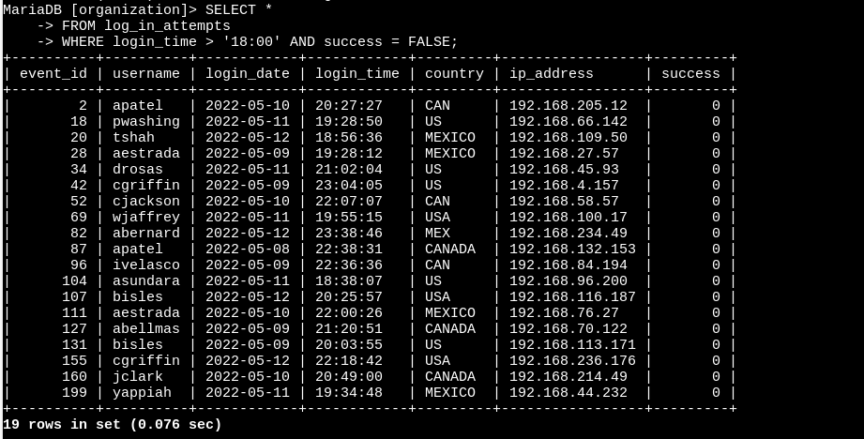

Retrieve login attempts on specific dates:

To retrieve login attempts on specific dates, I used the following SQL query:

SELECT *

FROM log_in_attempts

WHERE login_date = '2022-05-09' OR login_date = '2022-05-08';

This query selects all the records from the log_in_attempts table where the login time matches the specific date '2023-09-25' or the day before ‘2022-05-08’.

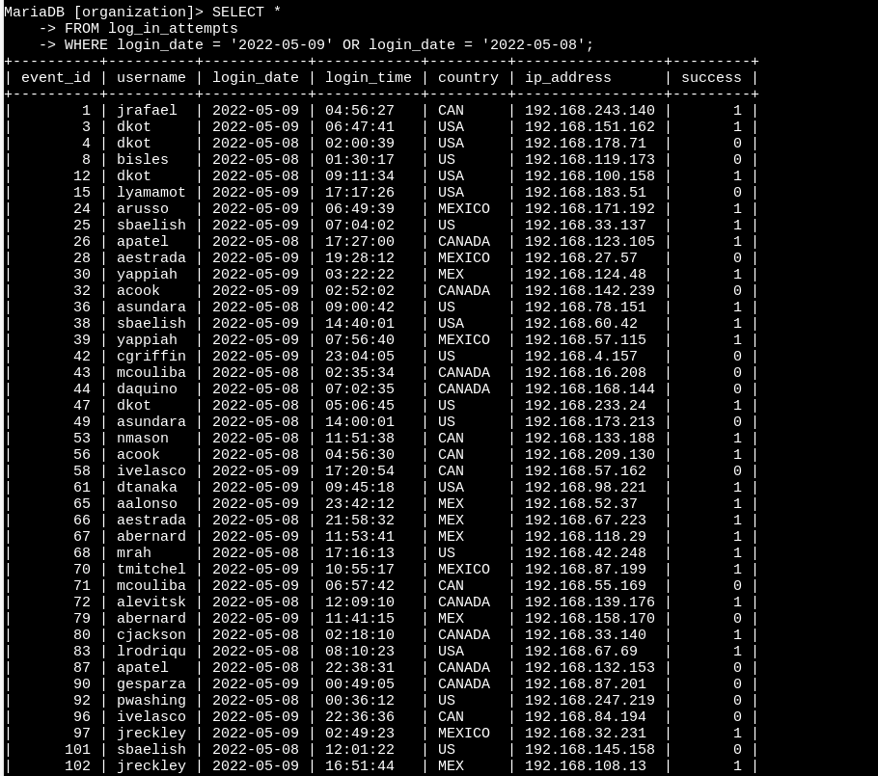

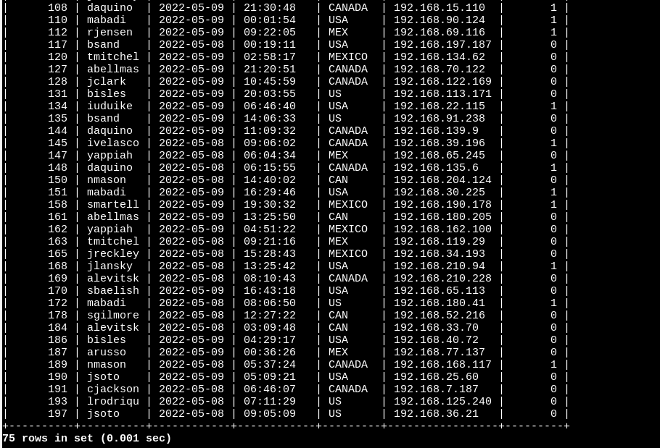

Retrieve login attempts outside of Mexico:

To retrieve login attempts outside of Mexico, I used the following SQL query:

SELECT *

FROM log_in_attempts

WHERE NOT country LIKE 'MEX%';

This query selects all the records from the log_in_attempts table where the location is not like country 'Mexico'.

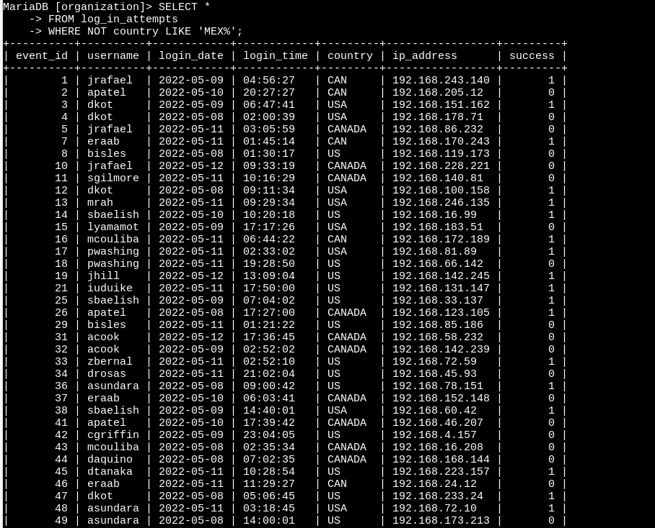

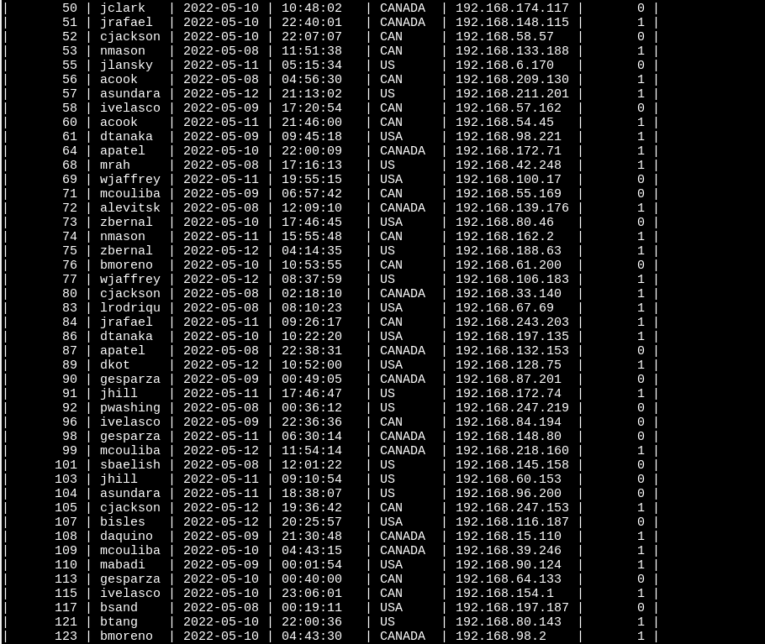

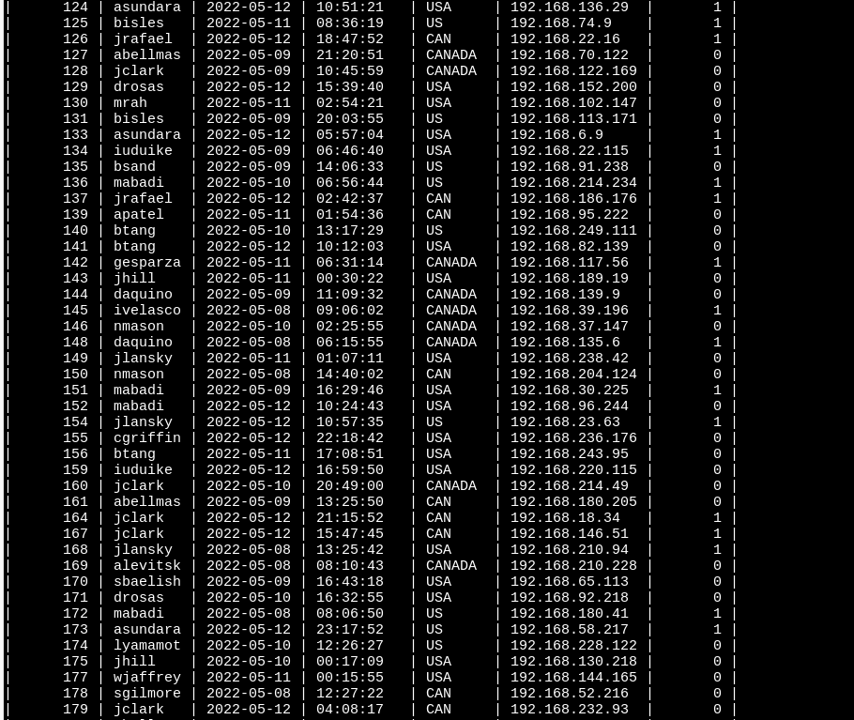

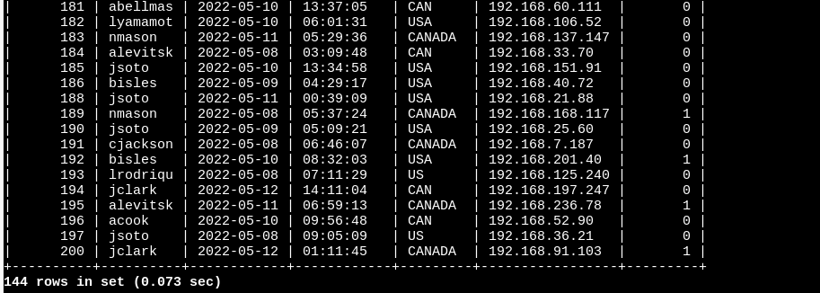

Retrieve employees in Marketing:

To retrieve employees in the Marketing department, I used the following SQL query:

SELECT *

FROM employees

WHERE department = 'Marketing' AND office LIKE 'East%';

This query selects all the records from the employees table where the department is 'Marketing' and who’s offices are located in the East Building.

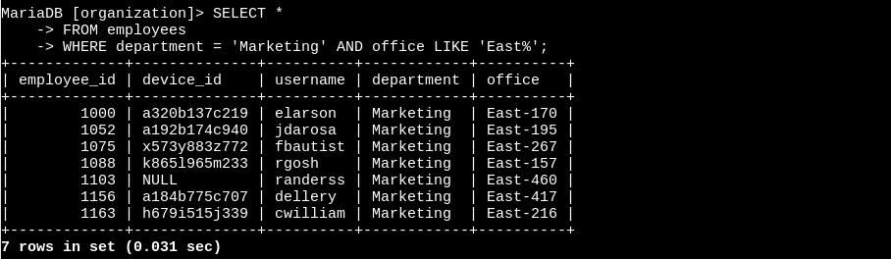

Retrieve employees in Finance or Sales:

To retrieve employees in the Finance or Sales departments, I used the following SQL query:

SELECT *

FROM employees

WHERE department = 'Finance' OR department = 'Sales';

This query selects all the records from the employees table where the department is either 'Finance' or 'Sales'.

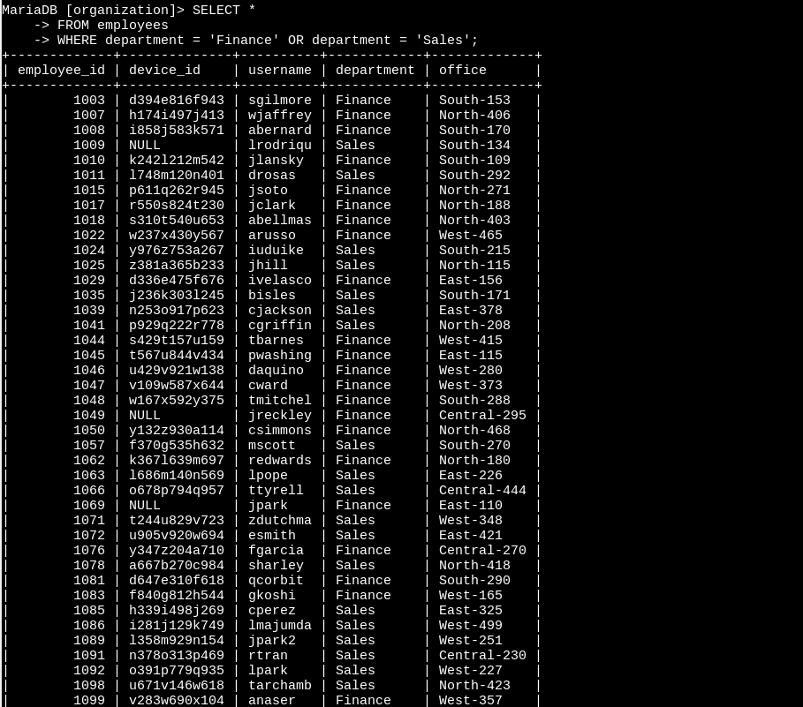

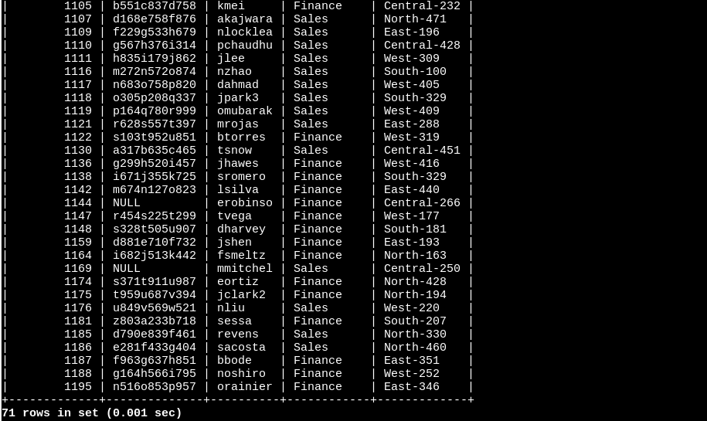

Retrieve all employees not in IT:

To retrieve all employees not in the IT department, I used the following SQL query:

SELECT *

FROM employees

WHERE NOT department = 'Information Technology';

This query selects all the records from the employees table where the department is not equal to 'Information Technology'.

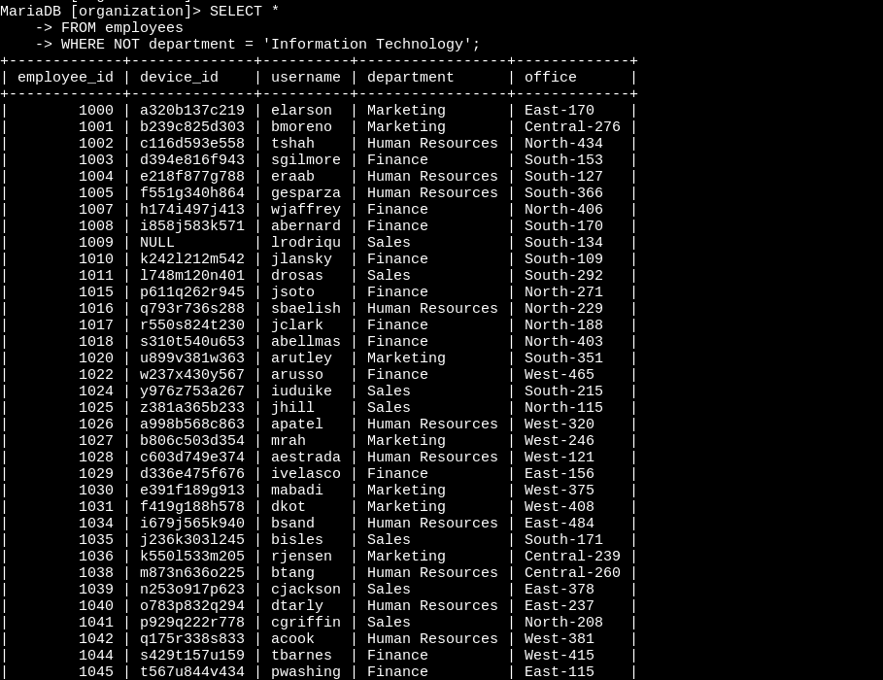

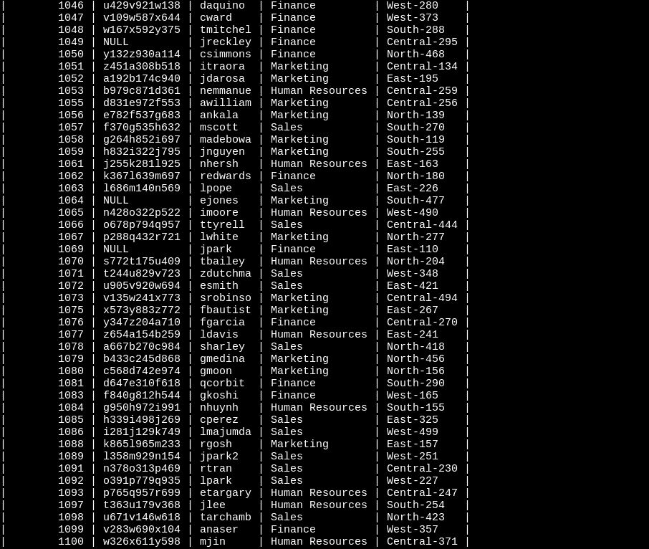

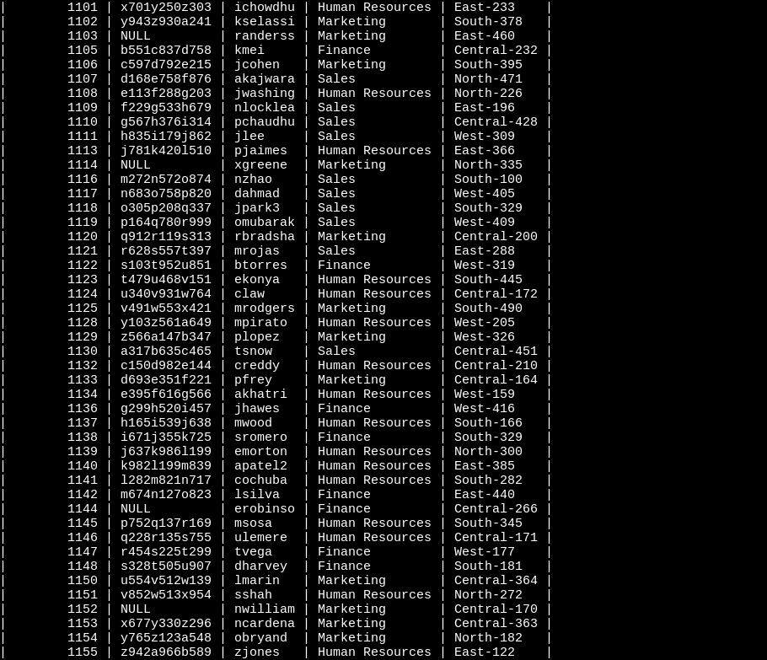

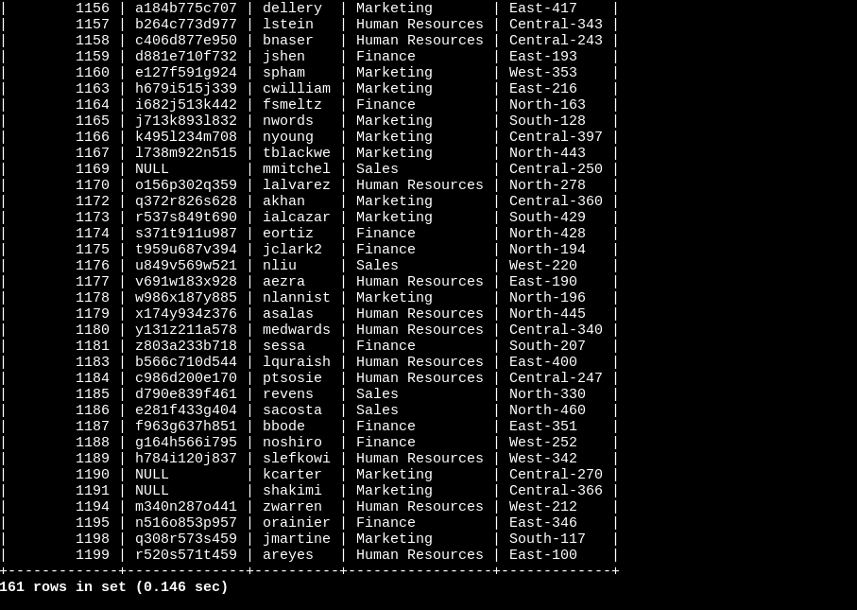

Summary:

Through SQL queries with applied filters, I was able to retrieve specific records from the employees and log_in_attempts tables to investigate potential security issues. I examined after hours failed login attempts, login attempts on specific dates, login attempts outside of Mexico, employees in Marketing, employees in Finance or Sales, and all employees not in Information Technology. These queries provided valuable insights into the security concerns and helped in assessing the overall system security.